Name: Amol Shivaji Tambekar Roll No:54 Batch:3

Create Database

In CouchDB, database is the outermost structure where documents are stored. CouchDB provides cURL utility to create databases. You can also use Futon the web interface of CouchDB.

Creating a database using Fauxton

Open the following link in the web browser:

http://127.0.0.1:5984/_utils/.

You will get a page like this:

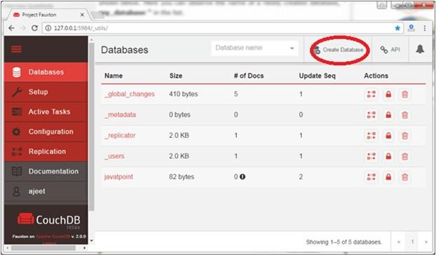

Click on the "Create Database" tab in the red circle to create a database named "employees".

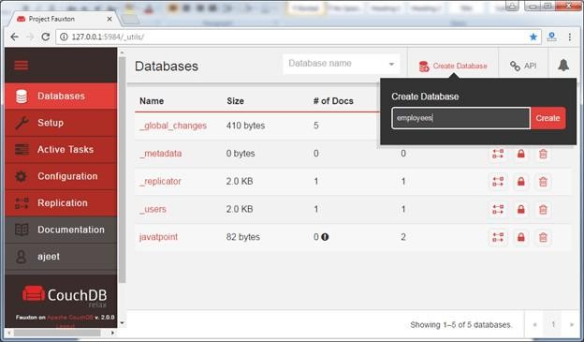

It will show a message that database is created successfully. You can check the created database in the database tab.
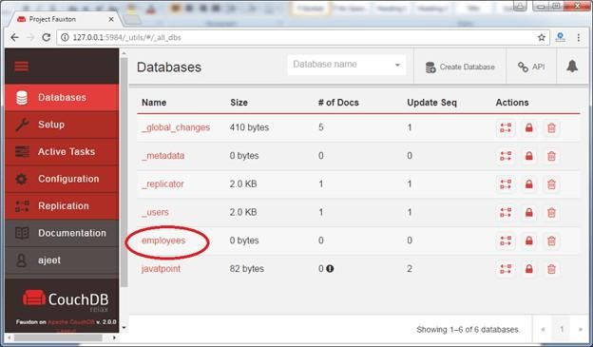

CouchDB Delete Database using Fauxton
Open the Fauxton url:http://127.0.0.1:5984/_utils/
Click on the "Databases" tab and you will see all databases:

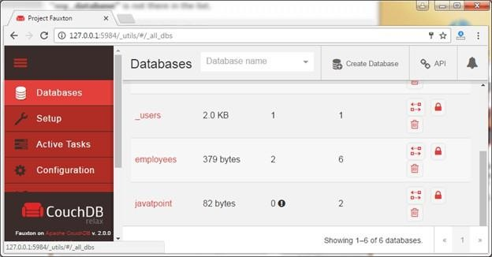

Here, we are going to delete "javatpoint" database. Click on the delete icon encircled in red.
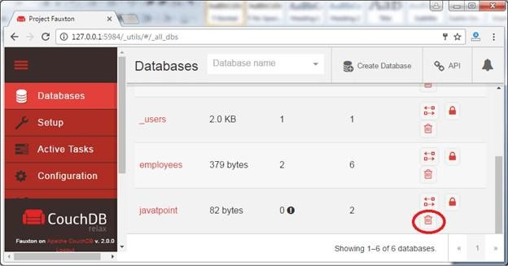

It will show a pop-up message asking to confirm the database name. Write down the name of the database.

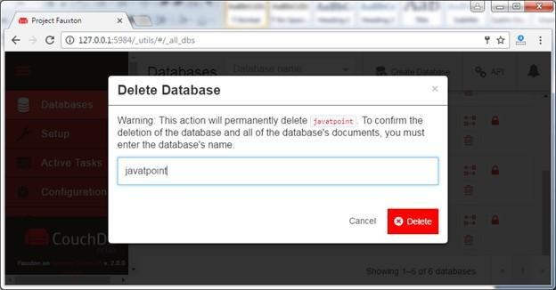

Now the database is deleted.

